***PAAREES PERFUMES***

***VERSACE***

***FOR WOMEN***

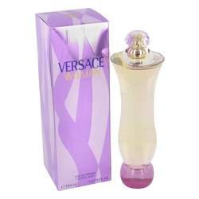

# 

# *Versace Woman*

# *Description:*

Versace Woman by Versace Perfume. Versace Woman is an enveloping fragrance from Versace. Developed for sophisticated women, it offers you a bouquet of floral scents accented with a hint of fruity sweetness. The fragrance was released in 2000, and it remains popular for everyday wear to the office and days out with friends. Overtones of rose and raspberry are detected first but are soon balanced by hints of plum and musk. Notes of blue cedar and inoke wood complete the scent's airy bouquet.